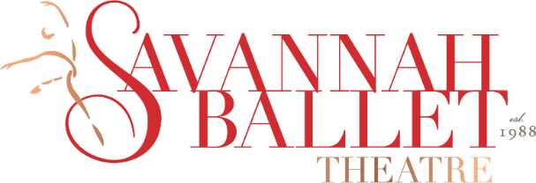

SAVANNAH BALLET THEATRE LAUNCHES NEW SPONSORSHIP PROGRAM TO SUPPORT DANCE FOR THE COMMUNITY
SAVANNAH, GA – September 22, 2020 – Savannah Ballet Theatre (SBT) has introduced a new sponsorship program inviting individuals and businesses to support the local nonprofit’s mission throughout the Lowcountry. This sponsorship program will aid the organization with community outreach and producing accessible productions for all, despite the challenges of the COVID-19 pandemic.
SBT is recognized as the premiere dance company in Southeast Georgia and has served the greater Savannah community for 21 years. This nonprofit arts organization regretfully cancelled their spring and fall shows due to the pandemic which resulted in loss of much-needed funds through ticket sales. Support is needed for the organization to continue bringing the art form of dance to the community, virtually and safely considering social distancing requirements.
SBT is looking for new partnerships to help further their mission to develop and showcase the talent of dedicated Savannah dancers alongside top professional dancers who train in the studio, and to engage in educational outreach and promotion of the art of dance within the community. Sponsorship levels range from $10,000 to sponsor a full production, $5,000 to sponsor a dancer for the season, and $600 to fund a dancer with ballet/pointe shoes. Other opportunities include sponsoring a guest artist, a patron, community engagement, and even the entire season. They offer in kind sponsorships and tailored sponsor packages to suit any business’s needs. As a sponsor, businesses or individuals will have the opportunity to connect with and be recognized in the community for their patronage.
“Our organization needs the community’s support to preserve the arts now more than ever,” said Board President Curt Bryant. “Taking part in this program will preserve Savannah’s own Ballet Theatre Company and provide work for artists during the ongoing pandemic. We urge businesses and individuals to support the arts for our community – please help us make it happen!”
This year, SBT launched a new organization, The Savannah Youth Ballet (SYB), to provide young dancers from the Southeastern USA the opportunity to become a vital part of a professional ballet company. Last year, SBT expanded their community outreach program by introducing low-sensory performances of their most popular production, The Nutcracker. These sensory-friendly performances were designed specifically for individuals with autism spectrum disorders, sensory sensitivities, or other disabilities. These are just a few ways SBT continues to reach new audiences to spread the joy of dance throughout Savannah.
Currently celebrating its 21st season, SBT was established in 1998 under the artistic direction of Suzanne Braddy. Recognized as the premiere dance company in Southeast Georgia, SBT is best known locally for its annual production of the perennial holiday favorite, The Nutcracker. SBT presents a full season of classical and contemporary dance every year. The beloved nonprofit organization is committed to creating and curating artistically forceful new productions which are based on adaptations of popular stories and movies. SBT is Savannah and southeast Georgia’s only professional dance company. It is their mission to develop and showcase the talent of dedicated Savannah dancers alongside top professional dancers who train in the studio, and to engage in educational outreach and promotion of the art of dance within the community.
For more information about SBT’s sponsorship program or to donate, please email donate@savannahballettheatre.org or call 912-200-9406 or visit the website www.savannahballettheatre.org.
-ENDS-
For media inquiries, please contact Crystal Vogel at crystal@lesleyfrancispr.com or 912-509-1510 or Kristyn Fielding at kristyn@lesleyfrancispr.com or 229-393-6457 or Lesley Francis at lesley@lesleyfrancispr.com or 912-429-3950 or the team at 912-417-LFPR (5377).

